Practical - 3

Practical Title: Responsive UI Design using CSS Grid, Flexbox, and Bootstrap/Tailwind
Problem Definition: Design responsive layouts for Home, About, Registration, Dashboard, and Events pages using CSS Grid and Flexbox. Optional to use CSS framework such as Bootstrap or Tailwind. Ensure mobile-first responsiveness.

Theory
  - How does the layout adapt for mobile, tablet, and desktop screens?
Answer: The layout changes using responsive CSS and media queries so it fits different screen sizes.

  - How does Which layout technique is used and why?
Answer: CSS Grid are used because they make layouts flexible, responsive, and easy to manage.

  - Are typography, spacing, colors, and contrast readable?
Answer: Yes. Proper font size, spacing, colors, and contrast make the content easy to read.

Implementation/ Output/Result

Style.css

*{

margin:0;

padding:0;

box-sizing:border-box;

font-family:Arial, Helvetica, sans-serif;

}

.first{

display:flex;

align-items:center;

justify-content:flex-end;

padding:20px 20px;

background-color:#f6f6f1;

}

.login , .signup{

margin-left:20px;

}

.login a , .signup a{

text-decoration:none;

color:#000;

}

header{

display:flex;

justify-content:space-between;

align-items:center;

padding:25px 8%;

}

.logo{

font-size:32px;

font-weight:bold;

color:#0c4f45;

}

nav ul{

display:flex;

list-style:none;

}

nav ul li{

margin-left:35px;

}

nav ul li a{

text-decoration:none;

color:#222;

font-weight:bold;

}

.hero{

display:flex;

align-items:center;

justify-content:space-between;

min-height:90vh;

padding:40px 8%;

}

.left{

width:75%;

}

.left h5{

color:#0c4f45;

font-size:24px;

margin-bottom:20px;

}

.left h1{

font-size:72px;

line-height:85px;

color:#0c4f45;

margin-bottom:30px;

}

.left p{

font-size:20px;

color:#555;

line-height:34px;

margin-bottom:40px;

}

.buttons{

display:flex;

gap:20px;

}

.btn1{

background:#0c4f45;

color:white;

padding:16px 35px;

border-radius:8px;

text-decoration:none;

font-weight:bold;

}

.btn2{

border:2px solid #0c4f45;

color:#0c4f45;

padding:16px 35px;

border-radius:8px;

text-decoration:none;

font-weight:bold;

}

.section{

width:90%;

margin:70px auto;

}

.section h2{

text-align:center;

font-size:38px;

color:#0c4f45;

margin-bottom:35px;

}

.section h2:hover{

text-decoration:underline;

}

.cards{

display:grid;

grid-template-columns:repeat(auto-fit,minmax(250px,1fr));

gap:25px;

}

.card{

background:#fff;

padding:25px;

border-radius:15px;

box-shadow:0 10px 20px rgba(0,0,0,0.08);

transition:0.3s;

}

.card:hover{

transform:translateY(-8px);

}

.card h3{

color:#0c4f45;

margin-bottom:15px;

}

.card p{

color:#666;

line-height:1.6;

}

.events{

display:grid;

grid-template-columns:repeat;

gap:25px;

}

.contact-container {

display: flex;

}

.contact-info {

width: 50%;

background-color:#0c4f45;

border-radius : 10px;

margin : 10px;

padding: 30px;

color: #fff;

}

.contact-info h3{

margin-bottom: 15px;

margin-left: 13px;

}

.contact-info p{

margin-bottom: 15px;

margin:15px;

}

.contact-info h3 p{

margin-bottom: 15px;

}

Login.css

*{

margin:0;

padding:0;

box-sizing:border-box;

font-family:Arial, Helvetica, sans-serif;

}

header{

display:flex;

justify-content:space-between;

align-items:center;

padding:25px 8%;

}

.logo{

font-size:32px;

font-weight:bold;

color:#0c4f45;

}

nav ul{

display:flex;

list-style:none;

}

nav ul li{

margin-left:35px;

}

nav ul li a{

text-decoration:none;

color:#222;

font-weight:bold;

}

.login {

text-align: center;

color: #0c4f45;

}

.form {

display: flex;

flex-direction: column;

text-align: center;

width: 300px;

margin: auto;

}

.form input , .form button {

padding: 8px;

margin-bottom: 5px;

}

.form select {

padding: 8px;

margin-bottom: 5px;

}

.form button {

background-color: #0c4f45;

font-size: large;

color: #fff;

border: none;

border-radius: 3em;

cursor: pointer;

}

.username {

text-align: center;

}

Register.css

*{

margin:0;

padding:0;

box-sizing:border-box;

font-family:Arial, Helvetica, sans-serif;

}

header{

display:flex;

justify-content:space-between;

align-items:center;

padding:25px 8%;

}

.logo{

font-size:32px;

font-weight:bold;

color:#0c4f45;

}

nav ul{

display:flex;

list-style:none;

}

nav ul li{

margin-left:35px;

}

nav ul li a{

text-decoration:none;

color:#222;

font-weight:bold;

}

.login {

text-align: center;

color: #0c4f45;

}

.form {

display: flex;

flex-direction: column;

text-align: center;

width: 300px;

margin: auto;

}

.form input , .form button {

padding: 8px;

margin-bottom: 5px;

}

.form select {

padding: 8px;

margin-bottom: 5px;

}

.form button {

background-color: #0c4f45;

font-size: large;

color: #fff;

border: none;

border-radius: 3em;

cursor: pointer;

}

.username {

text-align: center;

}

Student.css

* {

margin: 0;

padding: 0;

box-sizing: border-box;

font-family: Arial, Helvetica, sans-serif;

}

body {

background: #f6f6f1;

color: #222;

}

/* for left navbar */

.header {

width: 250px;

height: 100vh;

position: fixed;

left: 0;

top: 0;

color: white;

background: #0c4f45;

padding: 30px 20px;

}

.header.active {

left: 0;

}

.header .logo {

font-size: 30px;

font-weight: bold;

margin-bottom: 40px;

}

.header ul {

list-style: none;

}

.header ul li {

margin: 8px 0;

}

.header ul li a {

display: block;

padding: 14px;

color: white;

text-decoration: none;

border-radius: 7px;

font-size: 16px;

}

.header ul li a:hover {

background: rgba(255,255,255,0.15);

}

.logout {

margin-top: 25px;

border-top: 1px solid rgba(255,255,255,0.3);

padding-top: 20px;

}

/* for top navbar */

header {

height: 75px;

background: white;

display: flex;

align-items: center;

padding: 0 5%;

box-shadow: 0 2px 8px rgba(0,0,0,0.08);

}

.menu {

font-size: 30px;

cursor: pointer;

color: #0c4f45;

margin-right: 25px;

}

.header-logo {

font-size: 28px;

font-weight: bold;

color: #0c4f45;

}

.student-name {

margin-left: auto;

font-weight: bold;

}

.main {

margin-left: 250px;

padding: 35px 45px;

}

.top-bar {

display: flex;

align-items: center;

justify-content: space-between;

margin-bottom: 30px;

}

.top-bar h2 {

font-size: 28px;

color: #0c4f45;

}

.student {

display: flex;

align-items: center;

font-weight: bold;

gap: 10px;

}

.welcome {

background: #0c4f45;

color:#fff;

padding: 30px;

border-radius: 15px;

margin-bottom: 30px;

}

.welcome h1 {

font-size: 38px;

margin-bottom: 10px;

}

.welcome p {

font-size: 18px;

}

.stats {

display: grid;

grid-template-columns: repeat(3, 1fr);

gap: 20px;

margin-bottom: 30px;

}

.stat-card {

background: #fff;

padding: 25px;

border-radius: 12px;

text-align: center;

box-shadow: 0 7px 18px rgba(0,0,0,0.08);

}

.main-grid {

display: grid;

grid-template-columns: 2fr 1fr;

gap: 25px;

}

.box {

background:#fff;

padding: 25px;

border-radius: 15px;

box-shadow: 0 7px 18px rgba(0,0,0,0.08);

margin-bottom: 25px;

}

.box h2{

color: #0c4f45;

margin-bottom: 20px;

}

.course {

display: flex;

align-items: center;

justify-content: space-between;

padding:16px 0;

border-bottom: 1px solid #eee;

}

.course:last-child {

border-bottom: none;

}

.course h3 {

margin-bottom: 5px;

}

.course p {

color: #777;

}

.assignment {

background: #f6f6f6;

padding: 15px;

margin-bottom: 16px;

border-left: 5px solid #0c4f45;

border-radius: 8px;

}

.assignment h3 {

margin-bottom: 5px;

}

.assignment p {

color: #666;

}

.event {

background: #f6f6f6;

padding: 15px;

margin-bottom: 16px;

border-left: 5px solid #0c4f45;

border-radius: 8px;

border-bottom: 1px solid #eee;

}

.event:last-child {

border-bottom: none;

}

.event h3 {

margin-bottom: 5px;

}

.event p {

color: #666;

}

.announcement {

background: #f6f6f6;

padding: 15px;

margin-bottom: 16px;

border-left: 5px solid #0c4f45;

border-radius: 8px;

border-bottom: 1px solid #eee;

}

.announcement:last-child {

border-bottom: none;

}

.announcement h3 {

margin-bottom: 5px;

}

.announcement p {

color: #666;

}

/* for my course */

.container {

width: 100%;

margin: auto;

}

.container h2 {

margin: 15px 0;

}

.container p {

margin: 15px 0;

}

table {

width: 100%;

border-collapse: collapse;

background: white;

border-radius: 10px;

overflow: hidden;

box-shadow: 0 8px 18px rgba(0, 0, 0, 0.08);

}

thead {

background-color: #0c4f45;

color: white;

}

th {

padding: 16px;

text-align: left;

font-size: 16px;

}

td {

padding: 16px;

border-bottom: 1px solid #eee;

color: #555;

font-size: 15px;

}

tbody tr:hover {

background-color: #f6f6f1;

}

tbody tr:last-child td {

border-bottom: none;

}

Evidence of Work (Screenshots)
  - Index
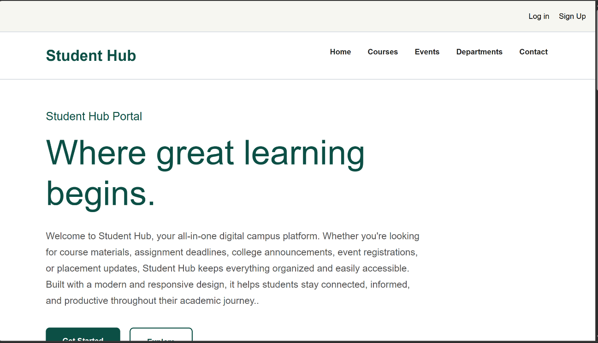



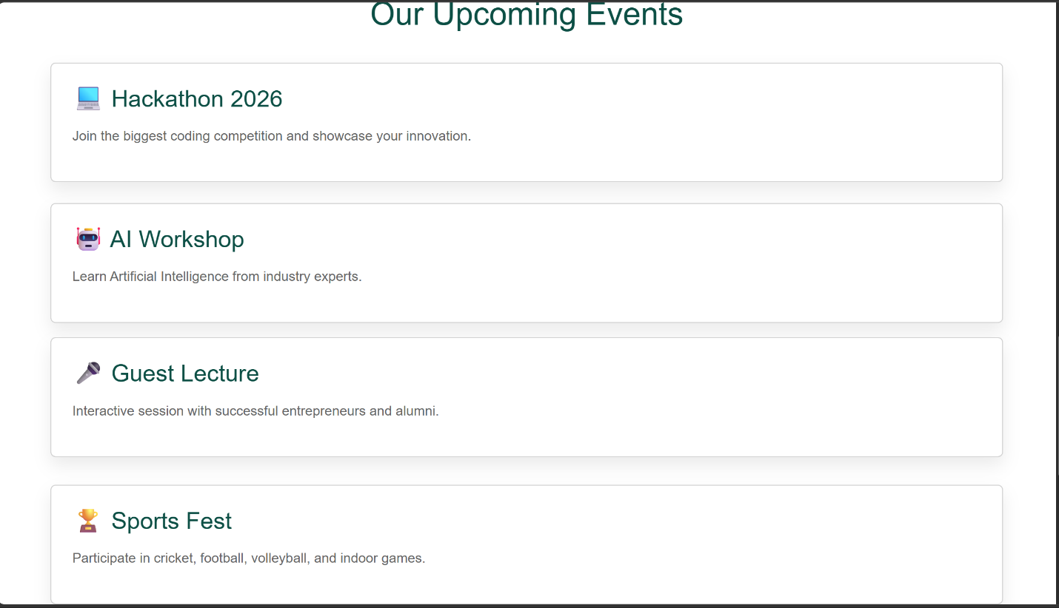



  - student dashboard
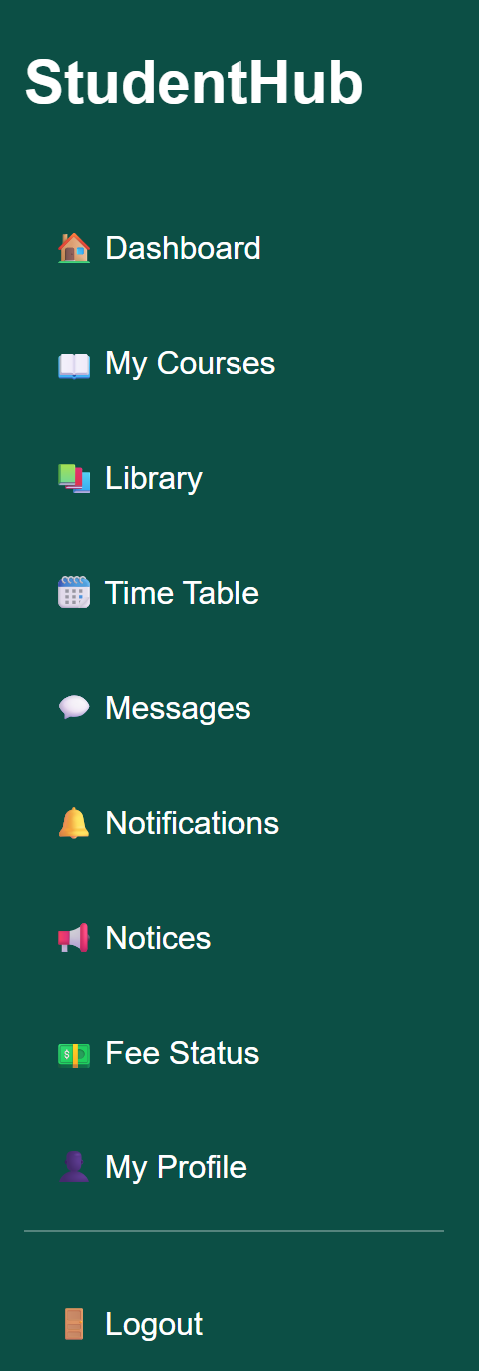

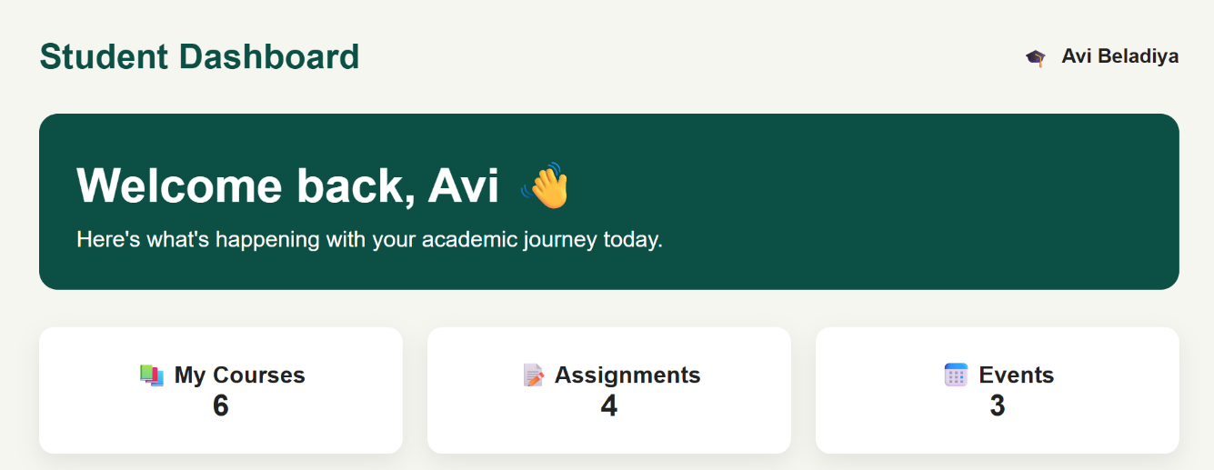

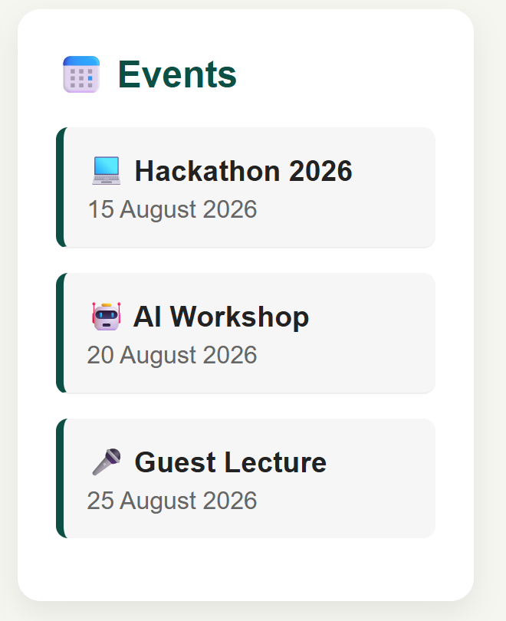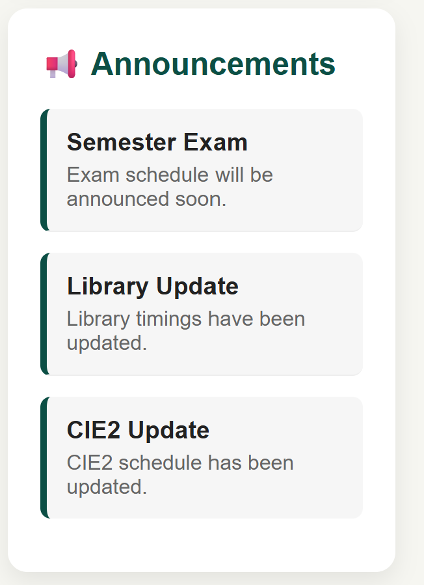

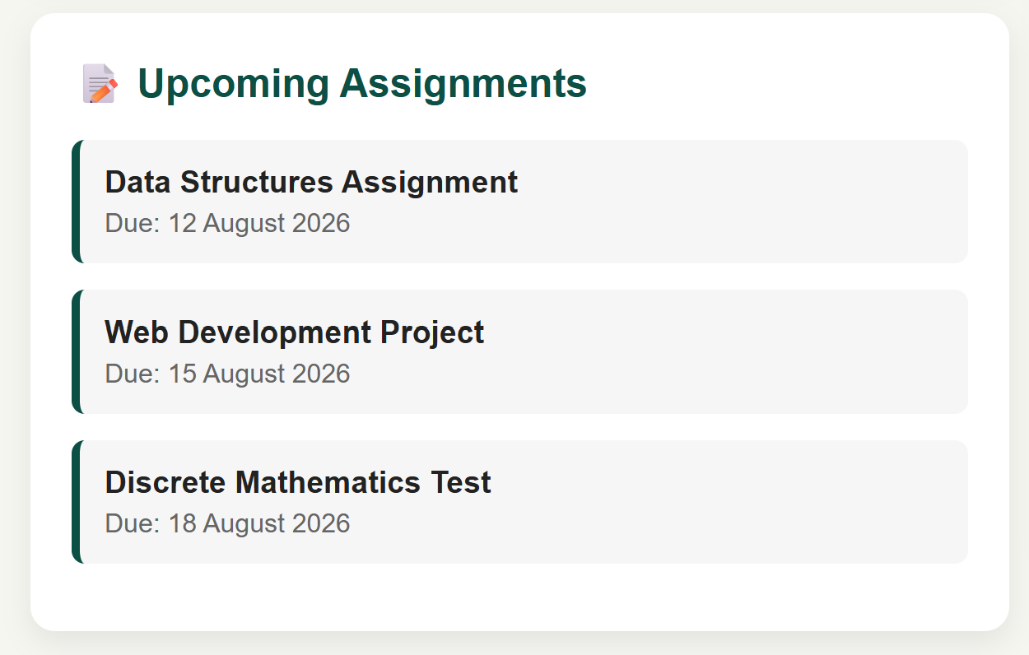

  - My course

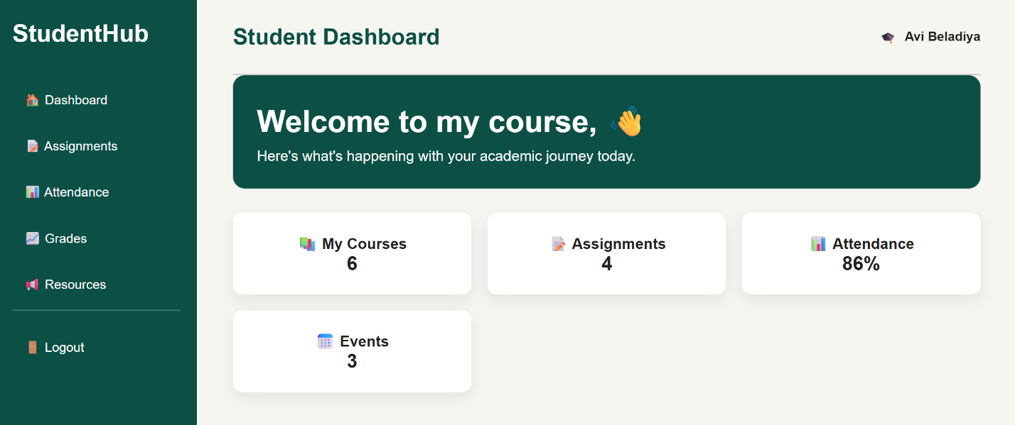

4.assignment

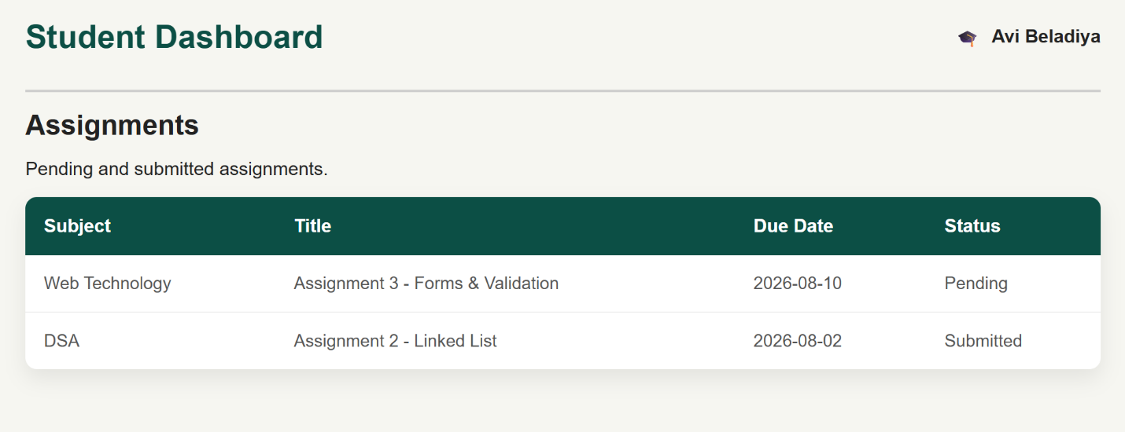

5.attendance

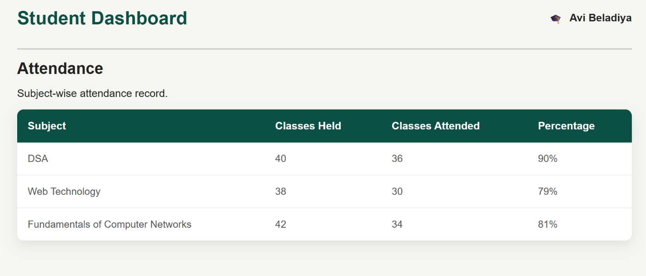

6. grades

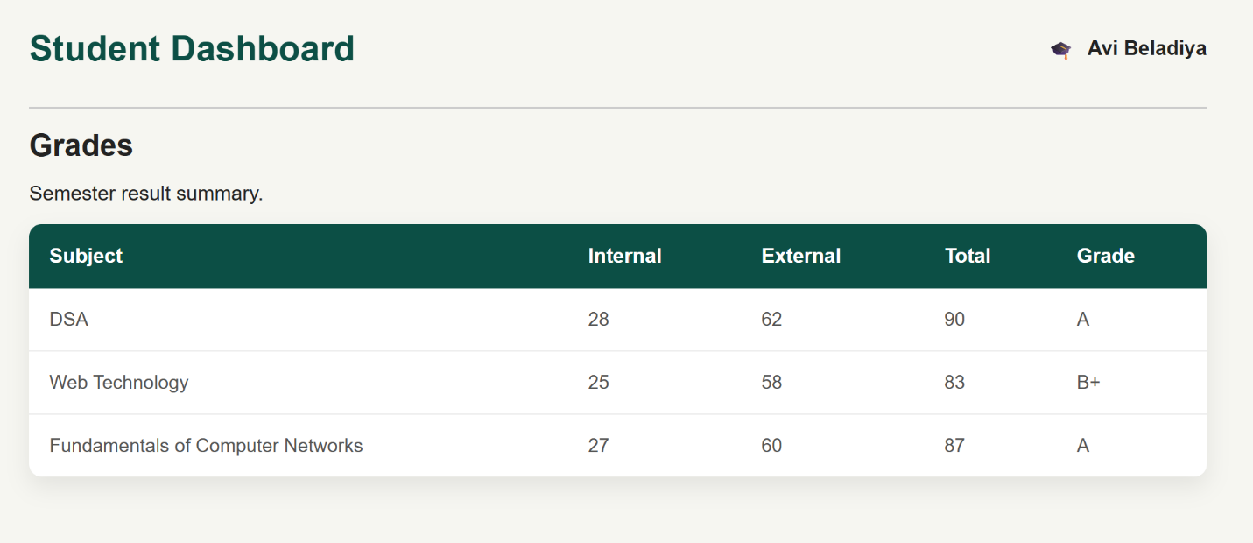

7.recources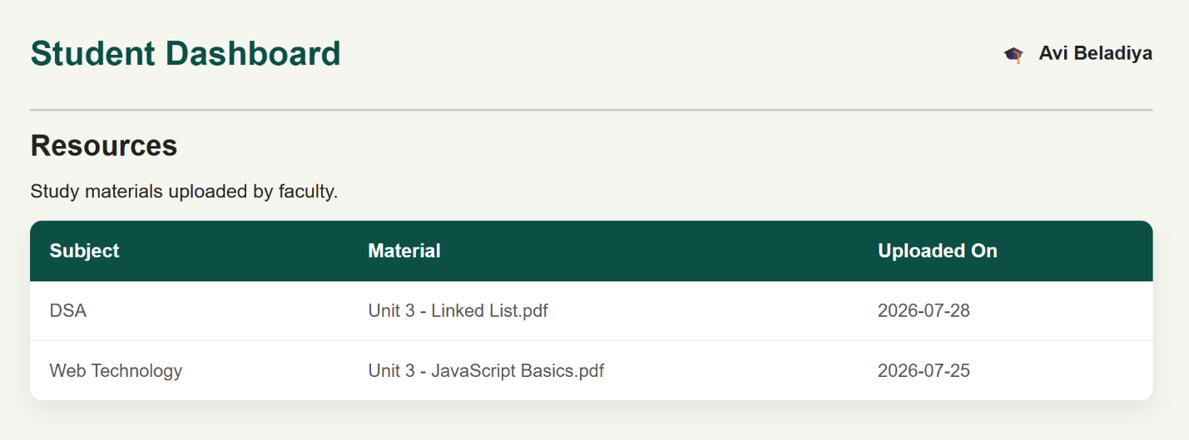

8.library

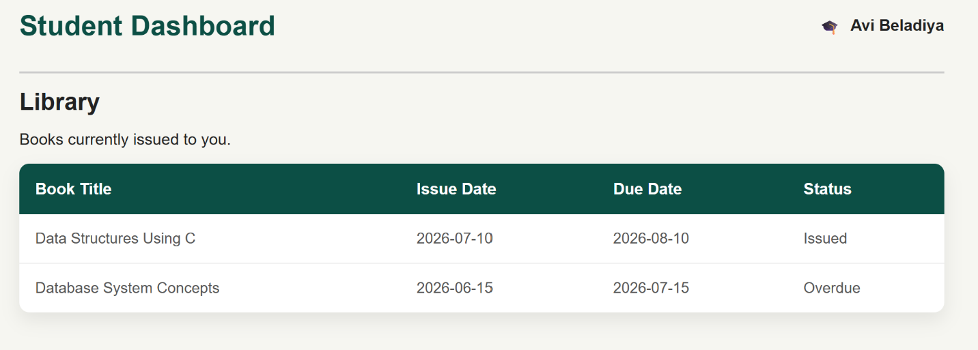
9.timetable

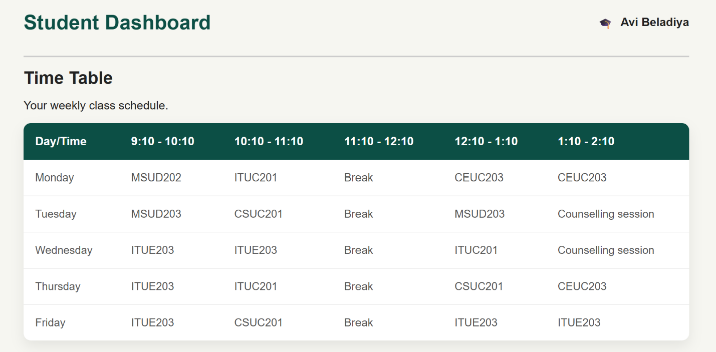

10.massages

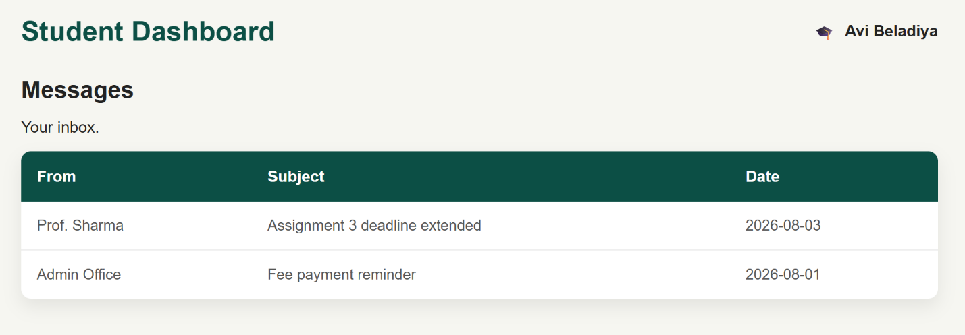

11.notifications

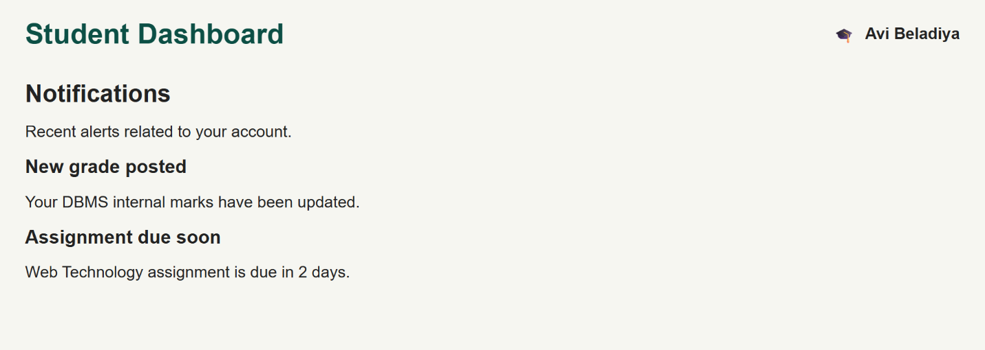

12.notices

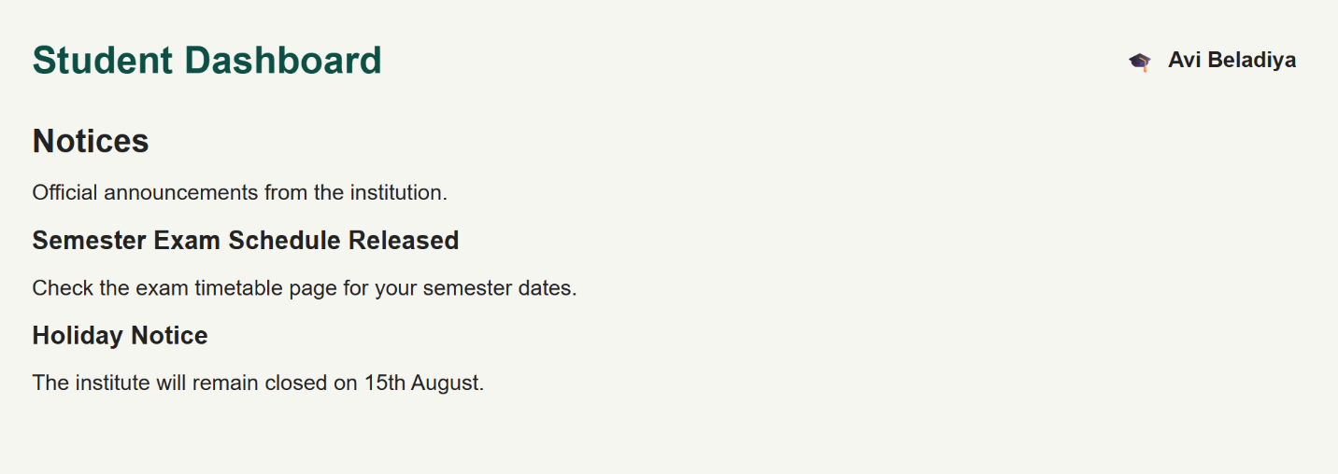

13.feestatus

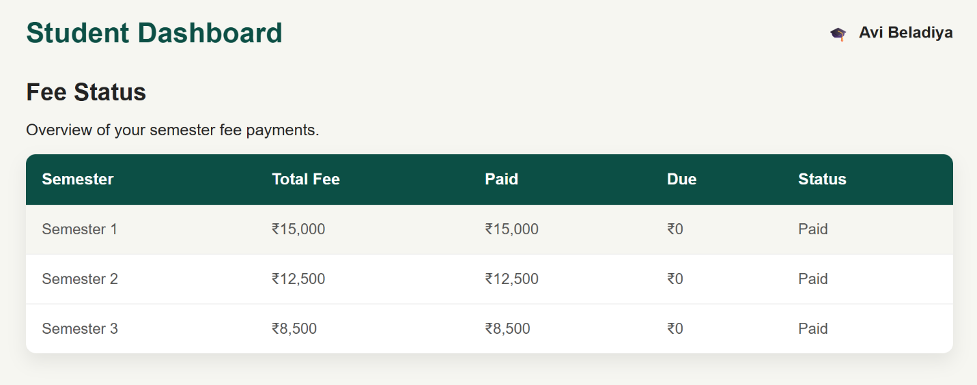

14.my profile

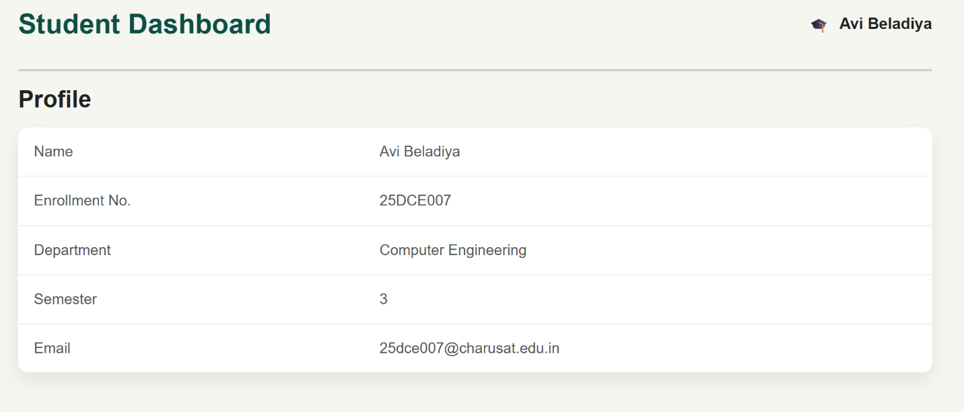

- GitHub Repository Link:

https://github.com/Avi4522/StudentHub.git
- Challenges Faced:
I faced some difficulty in applying the same CSS to all pages. I also had to fix alignment, spacing, and colors. After making changes, all pages looked consistent.

Learning Outcomes:
I learned how to use the same CSS on multiple pages. I also learned to keep the design consistent and make the website look clean and user-friendly.
Faculty Remarks:

